**Introduction to ASCII codes in Assembly language**

**LAB # 06**



**Fall 2021**

**CSE304L Computer Organization & Architecture**

Submitted by: **Ashfaq Ahmad**

Registration No: **19PWCSE1795**

Class Section: **B**

Student Signature: ______________

Submitted to:

**Prof: Ammad khalil**

December 13, 2021

**Department of Computer Systems Engineering**

**University of Engineering and Technology, Peshawar**

**Objective:**

* To know about uses of ascii code in assembly language.
* To make a simple calculator.

**Task 01:**

Write a program that take an alphabet and display its capital form.

**Source Code:**

.data

str: .asciiz"Name: Ashfaq Ahmad\nReg No: 19pwcse1795"

str1: .asciiz"\n\nplease enter any alphabit:"

str2: .asciiz"\nNow The capaital form of input Alphabit is: "

.text

main:

li $v0,4

la $a0,str

syscall

kh:

li $v0,4

la $a0,str1

syscall

li $v0,12 #for ascii input

syscall

move $t0,$v0

li $v0,4

la $a0,str2

syscall

addi $t1,$t0,-32

move $a0,$t1

li $v0,11 #for ascii number display

syscall

b kh

li $v0,10

syscall

**Output:**

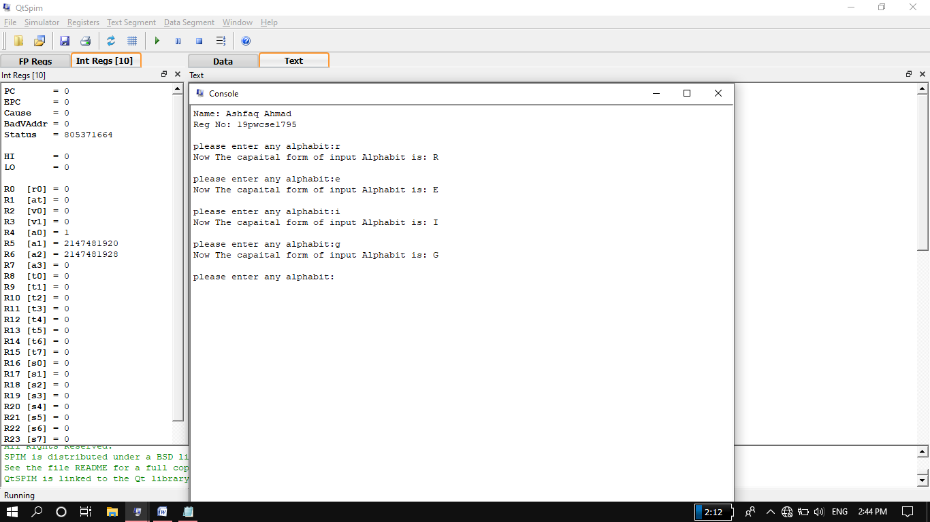

**Task 02:**

Write a program for a simple calculator.

**Source Code:**

.data

str: .asciiz"Name: Ashfaq Ahmad\nReg No: 19pwcse1795"

str1: .asciiz"\n\nPlease Enter num1:"

str2: .asciiz"Please Enter num2:"

str3: .asciiz"Please enter any operator:"

str4: .asciiz"\nThe Sum is: "

str5: .asciiz"\nThe Subtraction is: "

str6: .asciiz"\nThe Product is: "

str7: .asciiz"\nThe Quotient is: "

str8: .asciiz"\nThe Remender is: "

.text

main:

li $v0,4 #introduction display

la $a0,str

syscall

z:

li $v0,4 #system call for string display

la $a0,str1

syscall

li $v0,5 #first input

syscall

move $t0,$v0

li $v0,4

la $a0,str2

syscall

li $v0,5 #2nd input

syscall

move $t1,$v0

li $v0,4

la $a0,str3

syscall

li $v0,12 #when v0 contain 12 then it will take ascii code.

syscall

move $t2,$v0

li $s0,43 #addition operator code in decimal

li $s1,45 #Subtraction operator code in decimal

li $s2,42 #Multiplication operator code in decimal

li $s3,47 #Division operator code in decimal

beq $s0,$t2 addlabel

j exit

addlabel:

li $v0,4

la $a0,str4

syscall

add $t3,$t0,$t1

li $v0,1

move $a0,$t3

syscall

exit:

beq $s1,$t2 sublabel

j exit1

sublabel:

li $v0,4

la $a0,str5

syscall

sub $t3,$t0,$t1

li $v0,1

move $a0,$t3

syscall

exit1:

beq $s2,$t2 mullabel

j exit2

mullabel:

li $v0,4

la $a0,str6

syscall

mul $t3,$t0,$t1

li $v0,1

move $a0,$t3

syscall

exit2:

beq $s3,$t2 divlabel

j exit3

divlabel:

div $t0,$t1

li $v0,4

la $a0,str7

syscall

li $v0,1

mflo $a0

syscall

li $v0,4

la $a0,str8

syscall

li $v0,1

mfhi $a0

syscall

exit3:

b z

li $v0,10

syscall

**Output:**

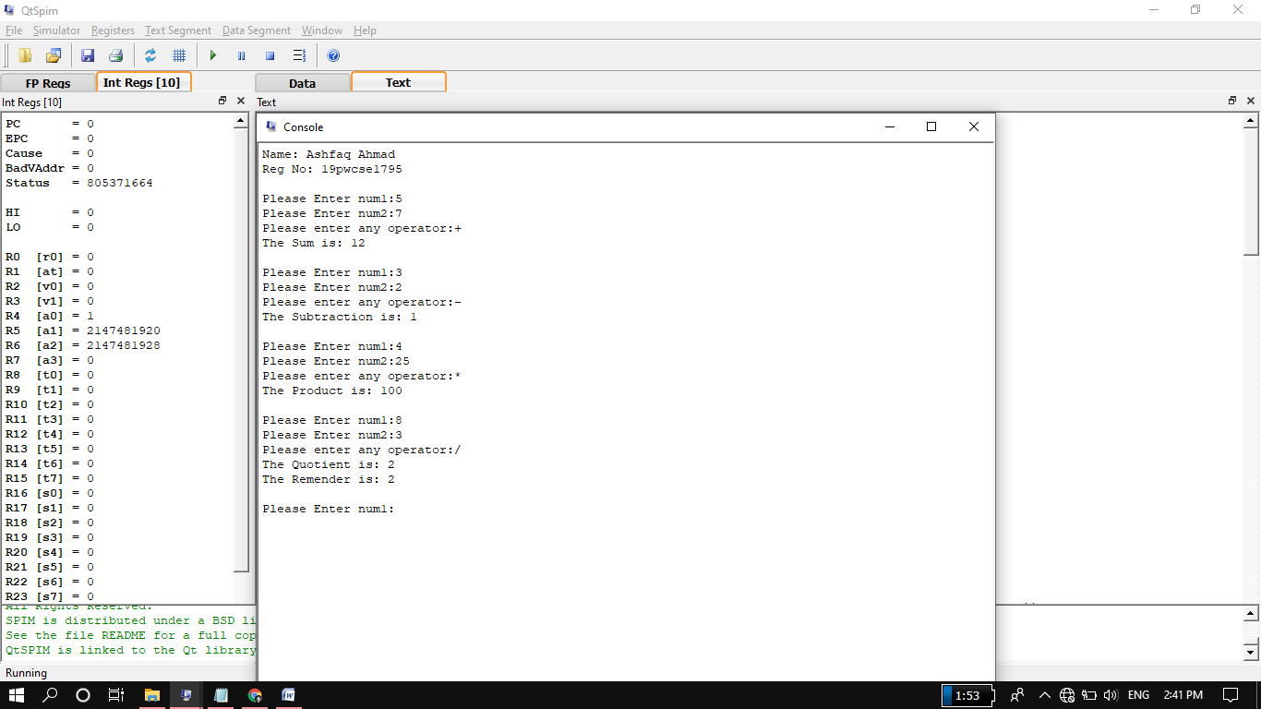

THE END